Camden Deuel
Question 1
Question 1a
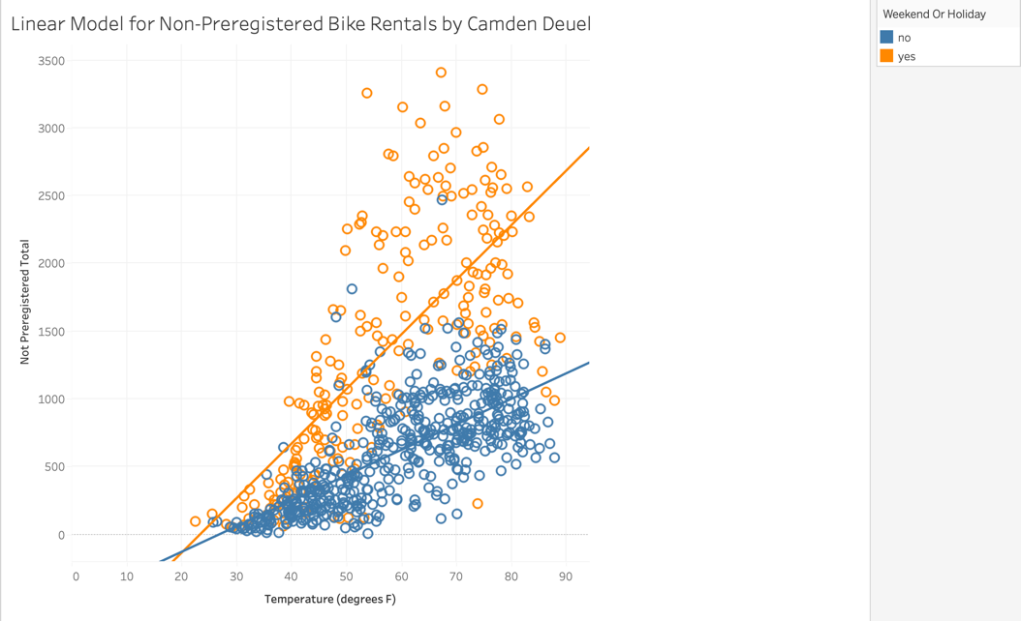
Question 1b
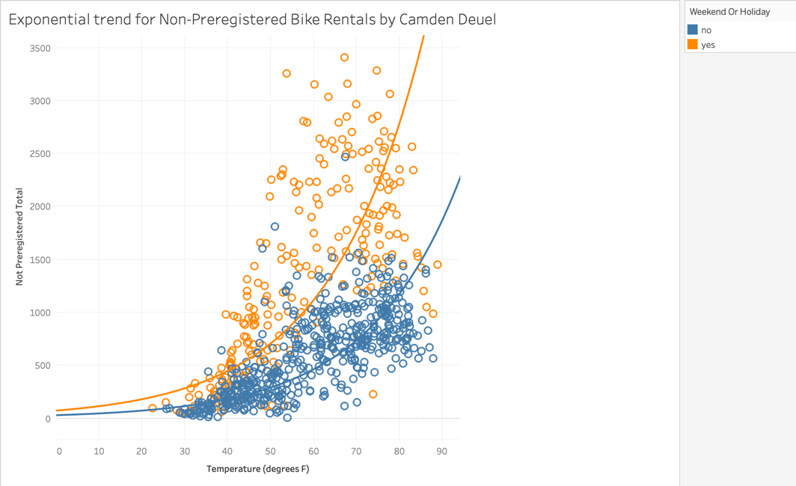
Question 1c
Looking at the plots above, I would conclude that an exponential model is better than a linear model to describe the relationship between the number of non-preregistered bike users with temperature and weekend/holiday status.
Question 2
Question 2a
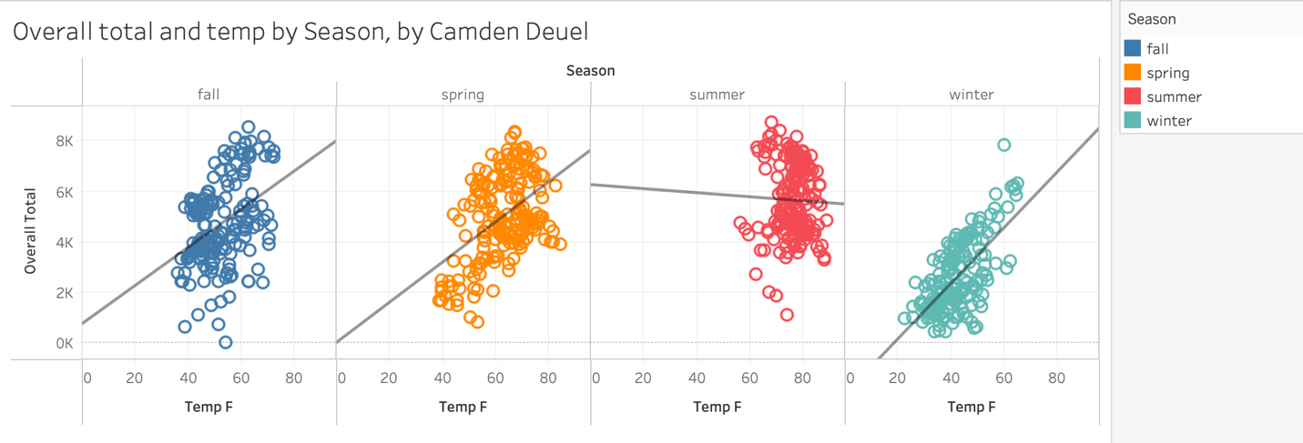
Question 2b
Season | Equation of the linear trend line  (slopes and intercepts rounded to the nearest whole number) | Is there a statistically significant correlation between overall total and temperature for this season? | R-squared value, which measures the strength of the correlation between overall total and temperature.
Winter | Predicted overall total = 110.206 *(tempF) + -2052.91 | Yes | 0.448016
Spring | Predicted overall total = 79.6638 *(tempF) + -0.724045 | Yes | 0.227591
Summer | Predicted overall total = -8.04145 *(tempF) + 6256.11 | No | 0.001045
Fall | Predicted overall total = 75.7211 *(tempF) + 743.998 | Yes | 0.158248

Question 3
Question 3a
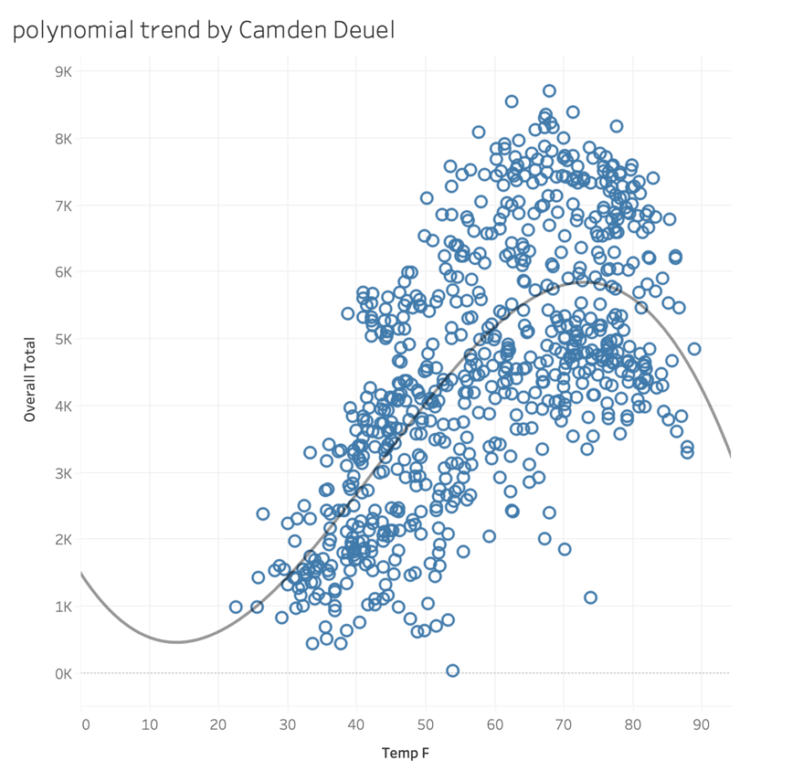
Question 3c
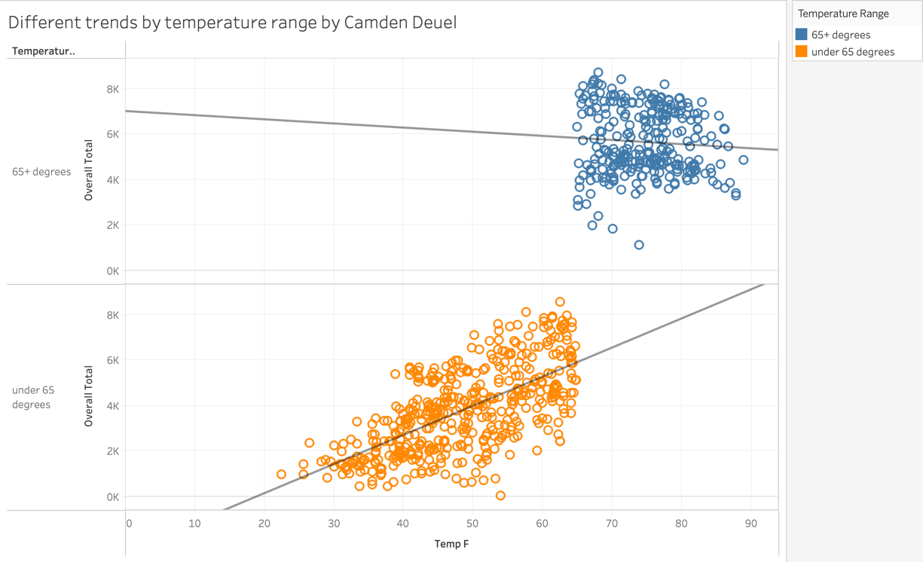
Question 3d
Temperature range | Equation of the linear trend line  (slopes and intercepts rounded to the nearest whole number) | Is there a statistically significant correlation between overall total and temperature for this temperature range? | R-squared value, which measures the strength of the correlation between overall total and temperature for this temperature range.
Less than 65 degrees | Predicted overall total = 127.985 *(tempF) + -2422.29 | Yes | 0.42731
65+ degrees | Predicted overall total = -18.1975 *(tempF) + 7003.8 | No | 0.245944

Question 4:
Question 4a
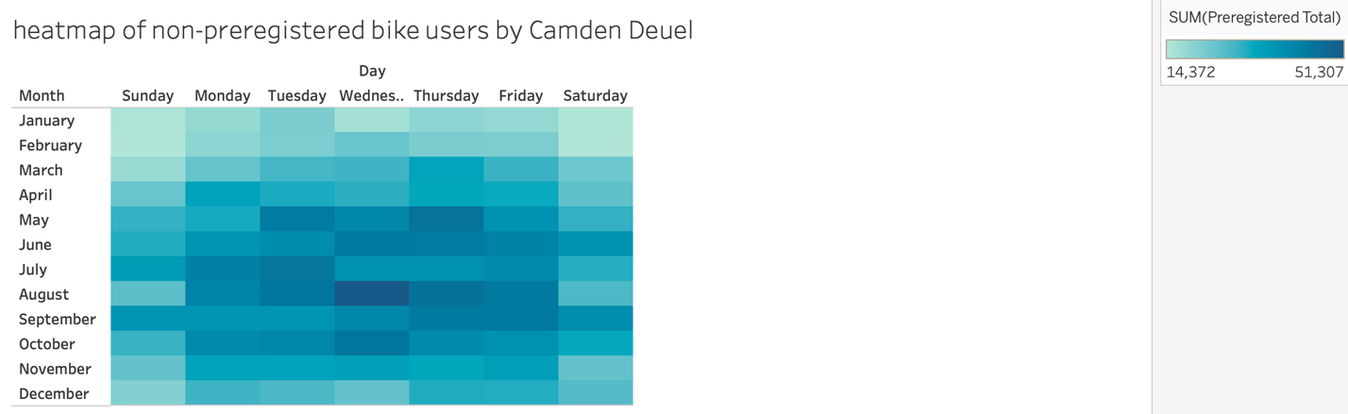
Question 4b
